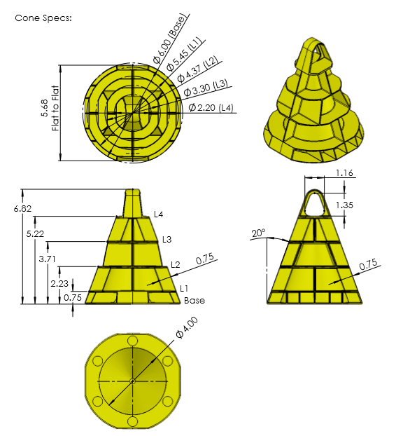Cones

The Cone object is without a doubt the most important object in “In the Zone”. Being a cone it is a somewhat awkward in shape. We predict that the two main methods of gripping will either be by grabbing it with a claw type device or lifting it using a rod slid through the eye. Another important factor to consider is that it is possible for cones to be knocked over. This means that designs will need to be able incorporate a separate (or perhaps integrated) method for picking up fallen cones.

Measurement on diagrams in inches

**Height:** 17.32 cm / 6.82"

**Width:**  15.24 cm / 6.00"

**Weight:** 118g ± 10%

**Amount:** 80

* 1 Preload
* 12 match loads
* 52 field

**Points:** 2

**Extra info:**

* Has a 3.43 cm eye
* Can be stacked

Mobile Goals

*Measurements on diagrams in inches*

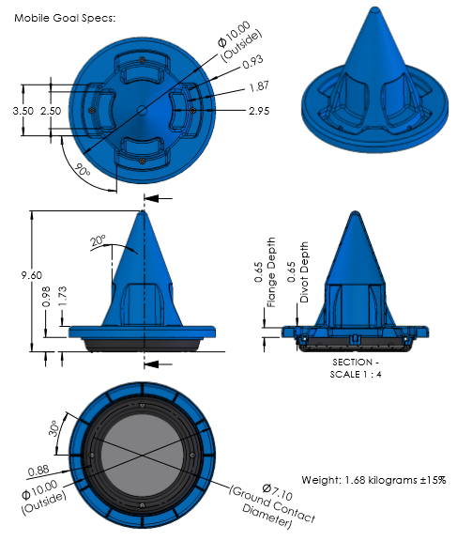

The Mobile Goal is crucial to scoring in the game “In the Zone”. Cones are scored by being stacked upon the mobile goal or the stationary goal. Being the used in the primary method of scoring it is important that our robot need to be able to grasp and move it. Like the cones, they are also prone to being knocked over, although it is arguably much harder to do due to its weight and low centre of mass. This means that the robot needs to be able to self-right the mobile goal to have any chance of succeeding

**Height:** 24.38 cm / 9.60"

**Width:**  25.40 cm / 10.00"

**Weight:** 1.68kg ± 15%

**Amount:** 8

* 4 red
* 4 blue

**Points:**

* 20 far zone
* 10 middle zone
* 5 close zone

**Extra info:**

* Cones can be stacked upon it

Stationary Goals

*Measurements on diagrams in inches*

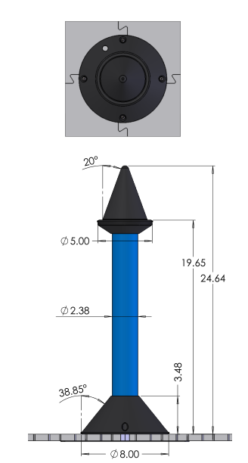

**Height:** 62.59 cm / 24.64"

**Width:**  20.32 cm / 8.00"

**Weight:** N/A

**Amount:** 2

* 1 red
* 1 blue

**Points:** N/A

**Extra info:**

* Cones can be stacked upon it
* Static

The Stationary Goals serve the same function as mobile goals with the only different being they are static and cannot be scored. Because of the singularity of their nature, starting height and immobility we suspect the stationary goals will be last goal that teams stack.

Stacking

*Measurements on diagrams in inches*

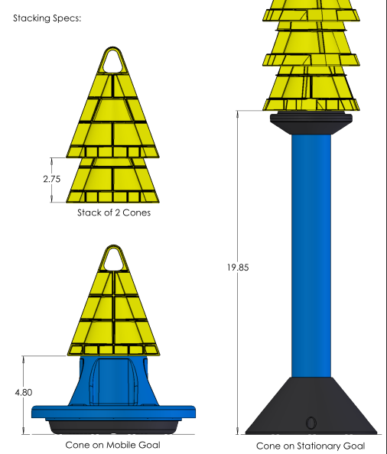

**Stationary Goal:**

19.85" + (n-1 * 2.75")

Mobile Goals give an elevation of 12.92cm / 4.80"

Stationary Goals give an elevation of 50.42cm / 19.85"

Stacked Cones give an elevation of 7.00cm / 2.75"

**Mobile Goal:**

4.80" + (n-1 * 2.75")

Table for heights of stacks

|  |  |  |  |
| --- | --- | --- | --- |
| Number of cones | Height on Mobile Goal(inches) | Weight (pounds) | Height on Stationary Goal (inches) |
| 1 | 11.8 | 4.0 | 26.9 |
| 2 | 14.6 | 4.2 | 29.6 |
| 3 | 17.3 | 4.5 | 32.4 |
| 4 | 20.1 | 4.7 | 35.1 |
| 5 | 22.8 | 5.0 | 37.9 |
| 6 | 25.6 | 5.3 | 40.6 |
| 7 | 28.3 | 5.5 | 43.4 |
| 8 | 31.1 | 5.8 | 46.1 |
| 9 | 33.8 | 6.0 | 48.9 |
| 10 | 36.6 | 6.3 | 51.6 |
| 11 | 39.3 | 6.6 | 54.4 |
| 12 | 42.1 | 6.8 | 57.1 |
| 13 | 44.8 | 7.1 | 59.9 |
| 14 | 47.6 | 7.3 | 62.6 |
| 15 | 50.3 | 7.6 | 65.4 |
| 16 | 53.1 | 7.9 | 68.1 |
| 17 | 55.8 | 8.1 | 70.9 |
| 18 | 58.6 | 8.4 | 73.6 |
| 19 | 61.3 | 8.6 | 76.4 |
| 20 | 64.1 | 8.9 | 79.1 |
| 21 | 66.8 | 9.2 | 81.9 |
| 22 | 69.6 | 9.4 | 84.6 |
| 23 | 72.3 | 9.7 | 87.4 |
| 24 | 75.1 | 9.9 | 90.1 |
| 25 | 77.8 | 10.2 | 92.9 |